AIR QUALITY MONITORING SYSTEM USING ARDUINO

MINI-PROJECT REPORT

Submitted by

ASWIN RAAJ R | (Reg.no: 202302011)
MANI BALAJI S | (Reg.no: 202302056)
THARUN VS | (Reg.no: 2023020108)

In partial fulfilment for the award of the degree of

BACHELOR OF ENGINEERING IN

ELECTRICAL AND ELECTRONICS ENGINEERING

 | DEPARTMENT OF ELECTRICAL AND ELECTRONICS ENGINEERING,  MEPCO SCHLENK ENGINEERING COLLEGE, SIVAKASI  (An Autonomous Institution affiliated to Anna University Chennai)

APRIL 2024

BONAFIDE CERTIFICATE

Certified that this project report titled “AIR QUALITY MONITORING SYSTEM USING ARDUINO “is the bonafide work of Mr.R.ASWIN RAAJ (REG.No:9517202302011), Mr.S.MANI BALAJI (REG.NO:9517202302056) and Mr.V.S.THARUN (REG.NO:95172023020 ) who carried out the mini-project under my supervision. Certified further, that to the best of my knowledge the work reported herein does not form part of any other project report or dissertation on the basis of which a degree or award was conferred on an earlier occasion on this or any other candidate.

Dr.G.Pandiaraj, M.E., Ph.D. Dr. N. Senthil Kumar, M.E., Ph.D.

Supervisor Head of the Department
Assistant Professor, (Sl.Grade) Senior Professor,
Department of Electrical and Electronics Department of Electrical and Electronics Engineering, Engineering,
Mepco Schlenk Engineering College, Mepco Schlenk Engineering College,
Sivakasi. Sivakasi.

Submitted for Viva-Voce Examination held at MEPCO SCHLENK ENGINEERING COLLEGE, SIVAKASI (AUTONOMOUS) on ……………..............

Examiner 1 | Examiner 2

ABSTRACT
Air pollution has become a major public health issue, and this system aims to monitor and assess levels of various air pollutants, specifically carbon dioxide (CO2), volatile organic compounds (VOCs), and combustible gases. The MQ-135 sensor is capable of detecting a wide array of gases and smoke, making it vital for evaluating air quality. The MQ-5 sensor is sensitive to lpg gas and other combustible gases.
The system is designed to provide immediate feedback on air quality, displaying current gas levels on a lcd display, which makes the user to monitor the air quality. The Arduino Uno acts as the central processing unit, converting analog sensor readings into meaningful digital values that can be easily interpreted . This integration enables users to assess air quality conditions in their environment quickly.
In addition to raising awareness about air quality, this project serves educational purposes, demonstrating how low-cost technology can contribute to public health monitoring. The system can be deployed in various settings, including homes and offices, to alert users to hazardous gas levels, thereby promoting healthier living conditions.
ACKNOWLEDGEMENT

An endeavour over a long period can be successful only with the advice and support of many well-wishers. First and foremost, we thank the lord almighty for his abundant grace and blessings for marking this work a great success.

We would like to extend our sincere gratitude to our honourable Principal Dr.S.ARIVAZHAGAN, M.E., Ph.D., FIETE. MISTE for providing ample facilities and necessary infrastructure during the course of the project.

We express our regards and thanks to our great support Dr.N.SENTHIL KUMAR,M.E., Ph.D., Senior Professor and Head of Electrical and Electronics Engineering Department for his cordial encouragement throughout the project.

We take great pleasure in expressing our deep sense of gratitude to
Dr.G.PANDIARAJ, M.E., PhD for his excellent guidance, encouragement and personal interest throughout the course of the project. Without his encouragement and guidance, this project would not have been materialized.

We also thank all the staff members and lab technicians of Electrical and Electronics Engineering Department for their kind co-operation in the completion of the project.
Finally we express our gratitude to our family and friends for their invaluable assistance throughout this project.

TABLE OF CONTENTS

S.No | Contents | Page.no
1. | Chapter 1: INTRODUCTION | 1
2. | Chapter 2: LITERATURE REVIEW | 3
3. | Chapter 3: SYSTEM DESIGN | 5
4. | Chapter 4: COMPONENTS AND MATERIALS | 8
5. | Chapter 5: CIRCUIT DESIGN | 13
6. | Chapter 6: SOFTWARE DEVELOPMENT | 17
7. | Chapter 7: SYSTEM IMPLEMENTATION | 22
8. | Chapter 8: TESTING AND RESULTS | 25
9. | CONCLUSION | 28
10. | FUTURE DIRECTIONS | 31
11. | REFERENCES | 35

TABLE OF FIGURES

S.No | Figure No. | Figure name | Page No.
 | 4.1 | Arduino UNO | 10
 | 4.2 | MQ-5 Gas Sensor | 11
 | 4.3 | MQ-135 Gas Sensor | 11
 | 4.4 | 16X2 LCD display with I2C | 11
 | 4.5 | DHT-11 Temperature and Humidity sensor | 12
 | 5.1 | Air Quality monitoring system block diagram | 17
 | 8.1 | Air quality table for MQ 135 gas sensor | 30
 | 8.2 | Results of air quality in serial monitor | 31
 | 8.3 | Air quality monitoring system using Arduino | 31

CHAPTER 1
INTRODUCTION

1.1 Importance of Air Quality Monitoring
Air quality monitoring is crucial in understanding and managing the levels of pollutants in our environment. As urbanisation and industrial activities increase, the potential for air pollution rises significantly, posing health risks to populations.
Poor air quality is linked to various health issues, including respiratory diseases, cardiovascular problems, and premature death. Continuous air quality monitoring is essential for regulatory compliance, public awareness, and health advisories. An effective air quality monitoring system can provide data that helps to identify pollution sources, track pollution trends, and inform the public about their exposure to harmful substances.

1.2 Overview of Air Pollutants
Air pollutants can be categorized into two main types: primary and secondary pollutants. Primary pollutants, such as carbon monoxide (CO) and nitrogen oxides (NOx), are emitted directly from sources like vehicles and factories. In contrast, secondary pollutants, including ozone (O3) and fine particulate matter , are formed through chemical reactions in the atmosphere from primary pollutants. Understanding the types of air pollutants is vital, as these substances can vary in their chemical composition, sources, and health impacts. They collectively influence overall air quality, necessitating effective detection methods to assess their presence in real time.

1.3 Objectives of the Project
The primary objective of this project is to design and implement an accessible Air Quality Monitoring System that utilizes Arduino technology in conjunction with MQ-135 and MQ-5 gas sensors. This system aims to provide real-time monitoring of key air pollutants, such as carbon dioxide (CO2) and liquefied petroleum gas (LPG), using an intuitive LCD for ease of use. The project also seeks to educate users about the importance of air quality and foster community engagement in environmental monitoring.
Ultimately, the project aims to demonstrate that individuals and local communities can utilize technology to actively monitor air quality conditions, advocating for improved public health and environmental stewardship.

1.4 Expected Impact on Public Health
Improving air quality monitoring has significant implications for public health. By providing real-time data on air pollution levels, early warnings can be issued to vulnerable populations, helping them take necessary precautions against harmful exposure. This project aims to empower individuals to make informed decisions regarding air quality, enhancing awareness of pollution levels in their immediate environment.
Furthermore, by demonstrating the use of low-cost air quality monitoring solutions, the project aims to inspire local governments and organizations to invest in similar initiatives. Increased commitment to monitoring air quality can lead to more effective public health policies and environmental regulations, fostering a healthier living environment for all.

1.5 Scope of the Project
The scope of this project encompasses the development of a functioning prototype for an Air Quality Monitoring System utilizing Arduino Uno, MQ-135, MQ-5 sensors, and an LCD display. It focuses on implementing the hardware and software components necessary for real-time monitoring of harmful gases in various environments, including urban, industrial, and residential areas.
The project will include circuit design, programming of the microcontroller, and testing of the assembled system. Though the prototype will initially measure a limited number of pollutants, future iterations may incorporate additional sensors to broaden its capabilities. The ultimate aim is to create a user-friendly system that can be easily replicated and adapted by community members or organisations interested in monitoring air quality.

CHAPTER II
LITERATURE REVIEW

2.1 Historical Context of Air Quality Monitoring
Historically, the monitoring of air quality dates back several decades, with early efforts primarily focused on assessing the impact of industrialization on urban environments. Initial measurement techniques involved complex instrumentation that was often expensive and limited to research or government use.
As public awareness of air pollution increased, so did regulatory measures, prompting the establishment of air quality standards. The introduction of national air quality monitoring networks helped provide baseline data on common pollutants, but access to real-time measurements remained limited. The advent of low-cost sensor technologies and microcontroller-based systems has begun to change this landscape, making air quality monitoring more accessible to the general public and fostering community engagement in environmental health.

2.2 Current Technologies in Use
Current air quality monitoring technologies vary widely in complexity, cost, and accuracy. Traditional monitoring stations utilize expensive equipment and are often operated by governmental agencies. However, recent advancements have led to the development of low-cost, portable, and user-friendly sensors that can be deployed by individuals or community organizations.
Technologies such as electrochemical sensors, laser-based systems, and optical sensors are becoming increasingly popular for detecting a range of air pollutants. Moreover, software applications can analyze data from these sensors, providing users with real-time feedback and actionable insights. As these technologies improve, they hold the potential to democratize air quality monitoring, enabling more people to participate in environmental stewardship.

2.3 Sensor Technologies Overview
Sensor technologies have evolved significantly to meet the growing demand for efficient and accurate air quality monitoring solutions. The MQ series of gas sensors, which includes the MQ-135 and MQ-5 used in this project, is well-regarded for its affordability and simplicity.
The MQ-135 can detect various gases, including benzene, alcohol, and carbon dioxide, making it versatile for numerous applications. The MQ-5 specializes in measuring concentrations of LPG and natural gas, vital for safety in residential settings. DHT 11 is a temperature and humidity sensor , which is used to give real time temperature and humidity of the surrounding which is directly related to air quality.
These sensors operate using a heating element and a sensitive material that reacts to the presence of specific gases, changing its resistance. Continued development in this area focuses on improving sensitivity, response time, and reducing cross-sensitivity to other gases.
2.4 Limitations of Existing Solutions
Despite significant advancements in air quality monitoring technologies, several limitations remain. Traditional monitoring stations are often limited in spatial coverage, focusing on urban areas while neglecting rural or less populated regions. The cost and complexity of these systems can be prohibitive for widespread deployment. Additionally, low-cost sensors, while beneficial, may have issues related to accuracy and calibration, particularly in variable environmental conditions. The lack of standardization in sensor technology can also lead to inconsistencies in data collection. Furthermore, data accessibility and sharing remain challenges, as many systems do not make real-time data available to the public. Addressing these limitations is crucial for developing more comprehensive, reliable, and user-focused air quality monitoring solutions.

CHAPTER III
SYSTEM DESIGN

3.1 System Functional Requirements
The Air Quality Monitoring System is designed to fulfill several functional requirements to meet the needs of users effectively. At its core, the system must accurately detect and measure concentrations of specific air pollutants, including CO2 and combustible gases such as LPG. Additional functional requirements include the ability to display these measurements in real time on an easily readable LCD interface, which allows users to quickly assess air quality without technical expertise.
The system should also provide auditory or visual alerts when pollutant levels exceed predetermined thresholds, enhancing user responsiveness to potential hazards. Finally, the design must be user-friendly in terms of setup, operation, and maintenance to encourage widespread adoption.

3.2 Hardware Architecture
The hardware architecture of the Air Quality Monitoring System consists of several integrated components that work together to achieve real-time air quality monitoring. The Arduino Uno microcontroller forms the backbone of the architecture, serving as the central processing unit that gathers input from the MQ-135 and MQ-5 sensors.
These sensors are strategically positioned to detect different air pollutants and pass their readings to the Arduino via analog input pins. The **LCD display** is connected through the I2C interface, allowing for simplified communication and clear visualization of air quality metrics. Proper circuit design ensures efficient power distribution and signal integrity, leading to stable sensor performance and accurate data output.

3.3 Software Architecture
The software architecture of the Air Quality Monitoring System is structured to facilitate seamless interaction between hardware components while ensuring reliable data processing. Starting with the Arduino IDE, the code is organized into modular segments, enabling clear function definitions for reading sensor data, calibrating measurements, and controlling the LCD output.
The main loop of the program continuously retrieves data from the sensors, applies necessary calculations for conversion into meaningful values, and updates the LCD display. Furthermore, the software architecture incorporates error handling functions to manage potential sensor malfunctions or unexpected readings, thereby maintaining overall system stability.

3.4 User Interface Design
The user interface design is a critical aspect of the Air Quality Monitoring System, focusing on simplicity and effectiveness. The system employs a 16x2 LCD display, which is straightforward and intuitive for users. The interface is designed to show real-time measurements of air quality parameters, such as CO2 and LPG concentrations, allowing users to easily gauge their environment's safety. Clear labelling of data displayed on the screen ensures immediate understanding. The information is refreshed every second, providing timely updates.
Additionally, if significant air quality thresholds are exceeded, the system will incorporate visual indicators or audible alerts to grab user attention quickly. This user-centric design encourages engagement and facilitates informed decision-making regarding air quality management.

3.5 Interaction Between Components
Effective interaction between components is vital for the successful operation of the Air Quality Monitoring System. The Arduino Uno serves as the central hub, interfacing with both the MQ-135 and MQ-5 gas sensors through designated analog pins that read voltage levels corresponding to gas concentrations.
The MCU processes these readings using programmed logic, interpreting the sensor data and converting it into understandable metrics. The information is then transmitted to the LCD, where real-time air quality reports are visually presented to the user. Power management is integral to this interaction, ensuring all components receive sufficient energy without interference. Additionally, to enhance usability, the system is designedallow easy modifications or upgrades, such as adding more sensors or integrating wireless communication features for data sharing.

CHAPTER 4
COMPONENTS AND MATERIALS

4.1 List of Required Hardware Components
The Air Quality Monitoring System utilizes a variety of hardware components that collectively enable its functionality. The primary component is the Arduino Uno, an open-source microcontroller board that drives the project through its computing capabilities. Accompanying this are two critical sensors: the MQ-135 and MQ-5 gas sensors, which are responsible for detecting a wide range of pollutants and DHT11 temperature and humidity measurement. The system also includes a 16x2 LCD to present real-time air quality data, making the system user-friendly. Additional components such as a breadboard will be used for prototyping, providing a platform for making circuit connections without soldering. Jumper wires connect different components, while a suitable power supply ensures the system operates reliably. This combination of elements ensures robust sensor performance and facilitates accurate measurements of air pollutants.

4.2 Specifications of the Arduino Uno
The Arduino Uno is a widely used microcontroller board based on the ATmega328P, known for its versatility and ease of use in various electronics projects. The board features 14 digital input/output pins, six analog inputs, PWM outputs, and a clock speed of 16 MHz. The USB connection allows for easy programming and power supply via a computer or external power sources. Additionally, the Arduino Uno operates on a voltage range of 7 to 12 volts, ensuring compatibility with various power supplies. Its programmable nature enables developers to write custom code to suit specific project needs, making it ideal for the Air Quality Monitoring System. The extensive libraries and community support available for the Arduino platform further enhance its appeal for hobbyists and researchers alike.

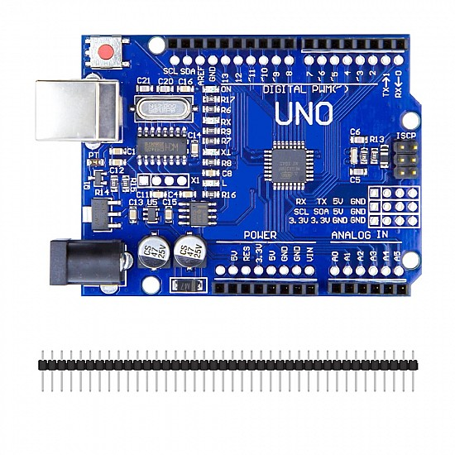
Figure 4.1 Arduino UNO
4.3 Detailed Description of MQ-135 and MQ-5 Sensors
The MQ-135 and MQ-5 sensors are pivotal elements of the Air Quality Monitoring System, each designed to detect specific pollutants. The MQ-135 sensor is highly sensitive and designed to detect multiple gases, making it suitable for measuring levels of CO2, alcohol, smoke, benzene, and other harmful gases prevalent in the air. Its operational range typically spans from 10 to 10,000 ppm, providing detailed insights into air quality.
On the other hand, the MQ-5 sensor specializes in detecting LPG, natural gas, and smoke, with lower detection limits than the MQ-135, making it particularly useful for safety applications. Both sensors operate using a heating element combined with a sensitive material that changes resistance in the presence of target gases, allowing for real-time gas concentration measurement. They are relatively easy to integrate with microcontrollers like Arduino due to their analog output, ensuring that the project can provide timely data to users effectively.

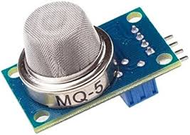 | 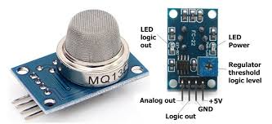
Figure 4.2. MQ-5 Gas Sensor | Figure 4.3. MQ-135 Gas sensor

4.4 Overview of the LCD Display
The 16x2 LCD display is an integral part of the user interface for the Air Quality Monitoring System, enabling real-time visualization of air quality metrics. This type of display features 16 columns and 2 rows, allowing for clear presentation of information. The display can show multiple readings simultaneously, such as the concentration of CO2 and LPG, making it user-friendly for quick assessments.
The LCD operates using the I2C interface, simplifying wiring and communication with the Arduino by reducing the number of pins required. It requires minimal configuration, and library support within the Arduino IDE ensures easy integration into the system's code. Additionally, the LCD’s backlight feature allows for visibility in various lighting conditions, enhancing user accessibility. By providing immediate feedback on air quality levels, this display plays a critical role in user engagement and awareness of environmental conditions.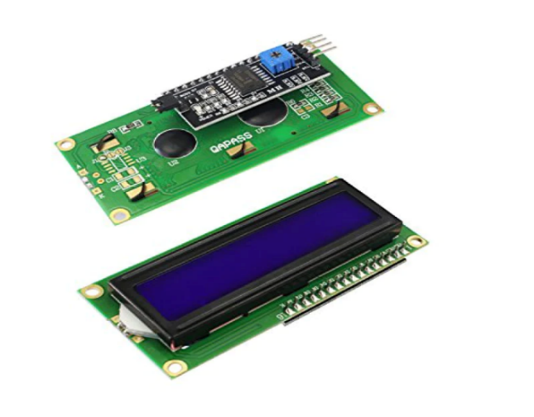Figure 4.4 16x2 LCD display and I2C module

4.5 DHT 11 Temperature and Humidity Sensor
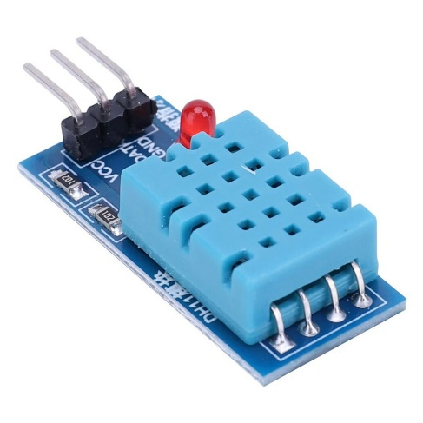
DHT11 – Temperature and Humidity sensor module Temperature and humidity sensors are important components of an air quality monitoring system. While they do not directly measure air quality parameters such as pollutants or particulate matter, they provide vital contextual information that helps in understanding air quality.
Figure 4.5 DHT-11 sensor
Why Temperature and Humidity Matter:
Air Quality Influence: Temperature and humidity can affect the concentration and behavior of air pollutants. For example, higher temperatures can increase the formation of ground-level ozone, while humidity can influence the amount of particulate matter in the air.
Health Impacts: High humidity can contribute to the growth of mold and dust mites, which can negatively impact indoor air quality and human health.
Data Correlation: By monitoring temperature and humidity alongside other air quality metrics (like CO2, VOCs, particulate matter), you can obtain a more complete picture of overall air quality conditions.
Comfort Levels: Indoor environments with optimal temperature and humidity levels are more comfortable and can help reduce health issues
4.5 Other Necessary Materials (Cables, Breadboards, etc.)
Apart from the main components, several other materials are necessary for the successful assembly and functionality of the Air Quality Monitoring System. A breadboard is essential for prototyping the circuit without soldering, allowing for easy modifications during development. Jumper wires facilitate connections between components, enabling signal and power transmission. Various wire lengths are beneficial for creating organized layouts and minimizing clutter.
Furthermore, a power supply is required to provide the necessary voltage and current to the components, which can be a USB connection from a computer or a battery pack for portability. Electrical tape or heat shrink tubing may also be used to secure connections and ensure safety by preventing short circuits. Additionally, optional materials such as resistors, capacitors, and wire connectors may be included for enhanced stability in circuit performance. Collectively, these materials support the overall effectiveness and reliability of the air quality monitoring prototype.
4.6 I2C Scanner
An I2C scanner is a useful tool for interfacing with a 16x2 LCD display to detect its I2C address, simplifying the process of communication between a microcontroller, like an Arduino, and the LCD. The 16x2 LCD with I2C interface uses only two data lines (SDA for data and SCL for clock), making wiring less cumbersome compared to using parallel connections.To use an I2C scanner, you typically upload a sketch that scans the I2C bus for connected devices. This program sends requests to the possible addresses (0x20 to 0x27 are common for many I2C LCD backpacks) and listens for acknowledgments. When it finds an address responding, it prints that address via the Serial Monitor.Once you have the correct address, you can easily communicate with the LCD using libraries like `LiquidCrystal_I2C`. This includes commands for setting up the display, printing text, and controlling backlight and cursor, which enhances user interaction in projects.
In summary, an I2C scanner streamlines the process of identifying your 16x2 LCD's address, enabling efficient coding and setup for various electronic projects that require visual output.

CHAPTER 5
CIRCUIT DESIGN

5.1 Overview of Circuit Components
The circuit design of the Air Quality Monitoring System involves a selection of essential components that work in harmony to facilitate real-time air quality monitoring. At the core of the circuit is the Arduino Uno, connected to various sensors and output devices. The MQ-135 and MQ-5 gas sensors are connected to the analog input pins, allowing the Arduino to read their resistance changes and convert these readings into gas concentrations.
The 16x2 LCD display connects through the I2C interface, simplifying wiring and enabling straightforward communication between the display and the Arduino. A solid power supply is critical; thus, a USB connection or battery provides the requisite voltage and current. In addition to these primary components, various resistors and capacitors may be included for filtering and stabilization, ensuring smooth operation of the sensors and minimizing noise from voltages. Together, these components form the backbone of the circuit, allowing for cohesive data collection, processing, and output.
5.2 Connection Details for Each Sensor
The connection details for each sensor are vital to the overall functionality of the Air Quality Monitoring System. The MQ-135 sensor requires connections to the Arduino board's analog input pin (commonly set to A0), as well as power (VCC) and ground (GND). The sensor's output voltage will vary based on the concentration of gases detected, allowing the Arduino to read these fluctuations.
Similarly, the MQ-5 sensor is connected to another analog input pin, often A1, while also serving the same power and ground requirements. Careful attention is paid to the pin layout to avoid miswiring. The LCD display utilizes two wire connections for power (VCC and GND) and four additional connections for I2C communication, usually designated SDA (data) and SCL (clock). Completing these connections ensures all sensors and display units effectively communicate with the Arduino, facilitating accurate data reporting and user feedback. This organized approach in wiring is crucial for maintaining signal integrity and reliability during operation.

5.3 Power Management Considerations
Power management is a critical aspect of the circuit design for the Air Quality Monitoring System, as reliable power supply is essential for smooth operation. The system generally operates on a 5V power supply, which can be provided through either a USB connection or an external battery pack. The choice of power source should consider factors such as portability and usage duration.
Including power regulators may also improve performance, ensuring that sensors receive a steady voltage without fluctuations that could lead to inaccurate readings. Proper power routing from a single source minimizes the complexity of wiring and the potential for short circuits. Moreover, implementing a power switch could enhance usability, allowing users to easily toggle the system on and off when not in use, preserving battery life. Effective power management not only guarantees that each component functions as intended but also promotes the longevity and reliability of the overall system.
5.4 Troubleshooting Common Circuit Issues
Troubleshooting common circuit issues is an essential aspect of ensuring the reliability and functionality of the Air Quality Monitoring System. Several problems may arise during the assembly or operation, such as incorrect wiring, loose connections, or faulty components. To begin troubleshooting, users should visually inspect the circuit for any obvious mistakes, ensuring that sensors are correctly connected to the designated pins on the Arduino.
Additionally, testing voltage at various points in the circuit can help identify power-related issues. If the LCD display does not light up or show data, users should verify that the I2C connections are secure and properly configured. Sensor calibration issues may also impact readings—if values appear consistently high or low, recalibration may be necessary. Using a multimeter for resistance measurement in the analog outputs can further clarify sensor performance. By effectively diagnosing and resolving these issues, users can maintain consistent operation and reliability in their air quality monitoring system.

5.5 Safety Precautions During Assembly
Safety precautions during the assembly of the Air Quality Monitoring System are essential to ensure a successful and secure construction process. Before starting, users should work in a clean, well-lit environment to minimize the risk of losing components or making assembly errors. Wearing safety glasses is advisable to protect against any accidental solder splashes, should a soldering iron be used.
Additionally, users should be cautious when handling electronic components, particularly sensors that involve heating elements, such as the MQ series. It is vital to allow any heated components to cool down before handling them. Furthermore, careful management of power connections is crucial: avoid connecting the circuit to power sources until the entire assembly is complete, reducing the risk of short circuits. Utilizing proper insulation for wire connections helps prevent accidental contact. Following these safety guidelines ensures not only personal safety but also helps maintain the integrity of the components and the overall system throughout assembly and eventual deployment.

5.6 Block diagram
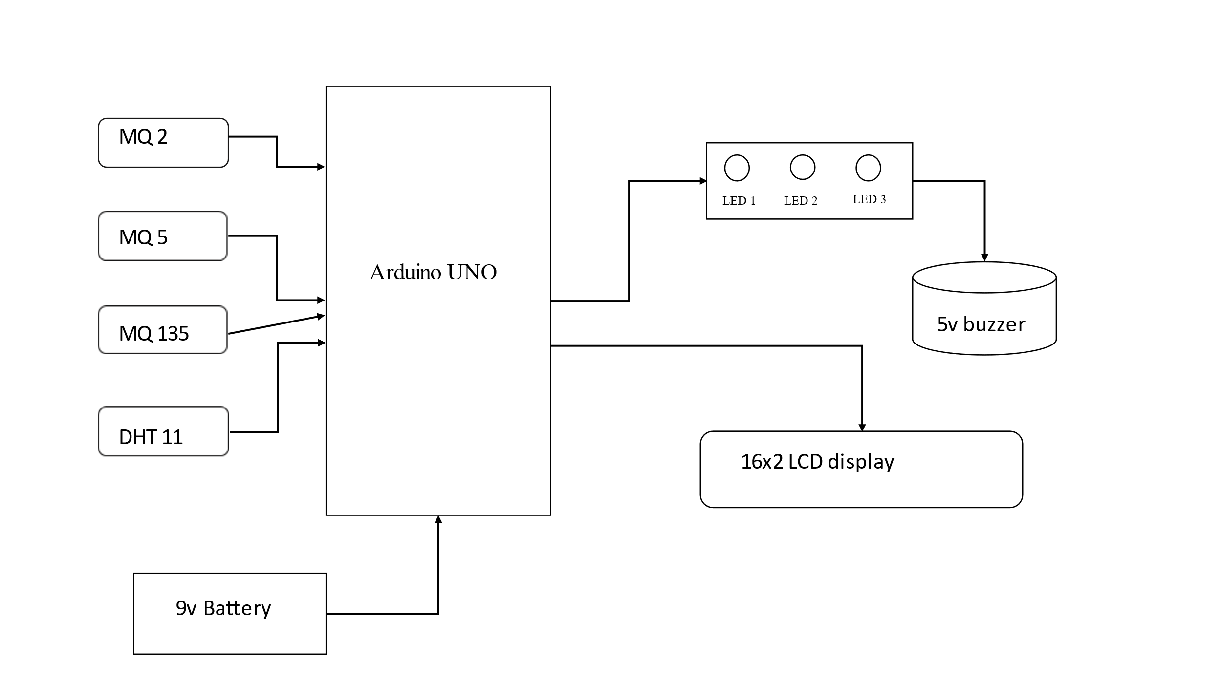
Figure 5.1 Air Quality Monitoring System

After uploading the code into Arduino uno microcontroller, the MQ-2, MQ-5, MQ-135 gas sensors and DHT-11 temperature and humidity sensor give some value because of the reaction of gases in the metal oxide layer in it. The Arduino converts that values into readable format which can be compared with known gas concentrations and can be calibrated based on that . When mq 5 value crosses known value for LPG leaking ,, then the led and buzzer will alert by glowing in sequential form. The power supply may be 9v battery or power supply from laptop USB port. By calibrating the MQ-135 gas sensor ,, it shows the quality of air by glowing LED. If the air quality is very worst , all the lights will glow so that it alerts the people real time.
CHAPTER 6
SOFTWARE DEVELOPMENT
6.1 Overview of Programming Language Used
The Air Quality Monitoring System employs the C/C++ programming language for software development, as it is supported natively by the Arduino IDE, the designated environment for writing and uploading code to the Arduino Uno. C/C++ offers powerful features for control over hardware components, making it a logical choice for projects involving various sensor integrations and real-time data processing. The syntax is straightforward, allowing both beginners and experienced programmers to effectively implement required functionalities.
In addition to the core programming language, the project utilizes various libraries to enhance code efficiency and simplify complex processes. These libraries provide pre-written functions for operations such as I2C communication with the LCD display and analog sensor reading. Employing libraries reduces the need for extensive programming and allows developers to focus on higher-level logic, ensuring quicker iterative development and reliable software performance. Overall, the choice of programming language and the use of supportive libraries are foundational elements in creating a robust and dependable air quality monitoring system.

6.2 Key Libraries Utilized (e.g., LiquidCrystal_I2C)
Key libraries play a pivotal role in the software development of the Air Quality Monitoring System, significantly streamlining the coding process and enhancing functionality. The LiquidCrystal_I2C library is among the primary libraries employed, enabling easy interaction with the LCD through I2C communication. This library allows developers to use fewer pins—two wires instead of multiple pins—simplifying circuit design while ensuring effective data transfer.
Additionally, the Wire library is crucial for I2C communication, facilitating direct digital communication between the Arduino and the LCD. Other potential libraries may include those for sensor data calibration, such as specific libraries for the MQ sensors, helping with the linearization of readings and accurate calculations of pollutant concentrations. By utilizing these libraries, the project leverages community-developed solutions that enhance code reliability and reduce development time, allowing the focus to be on overall system functionality rather than low-level coding intricacies.
6.3 Error Handling and Exceptions
Error handling and exceptions are vital for ensuring the reliability of the Air Quality Monitoring System. The software is designed to manage potential issues arising from sensor malfunctions or connectivity problems. For instance, the code checks the validity of readings from the MQ-135 and MQ-5 sensors, establishing predefined thresholds. If the sensors output values that are unrealistically low or high, the system triggers an alert on the LCD display, prompting the user to investigate the issue.
Moreover, timeout mechanisms are implemented to retry readings when communication with a sensor fails temporarily, maintaining data flow. Debugging features, such as serial print statements, are embedded within the code to help developers track the performance of the system during testing, pinpointing where errors occur. Through these error-handling strategies, the Air Quality Monitoring System can provide accurate air quality data, enhance user experience, and minimize disruptions caused by sensor-related issues.
6.5 Arduino Code
#include <Wire.h>
#include <LiquidCrystal_I2C.h>
#include <SimpleDHT.h>

LiquidCrystal_I2C lcd(0x27,16,2);
int i=0;
int n=100;
int good135=170;
int bad135=300;
int lpg_leak=900;
int pinDHT11 = 2;
SimpleDHT11 dht11(pinDHT11);

void setup()
{
lcd.init();
lcd.init();
// Print a message to the LCD.
lcd.backlight();
pinMode(8,OUTPUT);
pinMode(10,OUTPUT);
pinMode(9,OUTPUT);
pinMode(11,OUTPUT);
for(int pin=11;pin<=8;pin--)
{
digitalWrite(pin,HIGH);
delay(200);
digitalWrite(pin,LOW);
delay(50);
}
for(int pin=8;pin<=11;pin++)
{
digitalWrite(pin,HIGH);
delay(200);
digitalWrite(pin,LOW);
delay(50);
}
for(int pin=11;pin<=8;pin--)
{
digitalWrite(pin,HIGH);
delay(200);
digitalWrite(pin,LOW);
delay(50);
}
for(int pin=8;pin<=11;pin++)
{
digitalWrite(pin,HIGH);
delay(200);
digitalWrite(pin,LOW);
delay(50);
}
lcd.begin(16, 2);
lcd.setCursor(0,0);
lcd.print(" Welcome! ");
delay(500);
lcd.clear();
lcd.print(" Air Quality");
lcd.setCursor(0,1);
lcd.print(" Monitor ");
delay(500);
lcd.clear();

Serial.begin(9600);
}
void loop()
{

int gs135=analogRead(A0);
int gs5=analogRead(A1);

Serial.print(" A ");
Serial.println(gs135);
Serial.print(" B ");
Serial.print(gs5);
delay(1);
lcd.clear();

//
byte temperature = 0;
byte humidity = 0;
int err = SimpleDHTErrSuccess;//0
if ((err = dht11.read(&temperature, &humidity, NULL)) != SimpleDHTErrSuccess) {
Serial.print("Read DHT11 failed, err="); Serial.print(SimpleDHTErrCode(err));
Serial.print(","); Serial.println(SimpleDHTErrDuration(err)); delay(1000);
return;
}

lcd.setCursor(0,0);
lcd.print("Tem:");
lcd.setCursor(4,0);
lcd.print((int)temperature);
lcd.setCursor(6,0);
lcd.print("C");
lcd.setCursor(9,0);
lcd.print("Hum:");
lcd.setCursor(13,0);
lcd.print((int)humidity);
lcd.setCursor(15,0);
lcd.print("H");
delay(1);
lcd.setCursor(0,1);
lcd.print("AQ:");
delay(1);
if(gs5<=lpg_leak)
{
lcd.setCursor(3,1);
lcd.print(gs135);
if(gs135<good135&&gs135>0)
{

lcd.setCursor(7,1);
lcd.print("Good");
delay(1);
digitalWrite(9,LOW);
delay(100);
digitalWrite(8,LOW);
delay(100);
digitalWrite(11,LOW);
delay(100);
analogWrite(10,120);
delay(100);
}
else if(gs135>=good135&&gs135<bad135)
{
lcd.setCursor(7,1);
lcd.print("Moderate");
delay(1);
digitalWrite(10,HIGH);
delay(100);
analogWrite(9,180);
delay(100);
digitalWrite(8,LOW);
delay(100);
}
else if(gs135>=bad135)
{
lcd.setCursor(7,1);
lcd.print("Bad");
delay(1);
digitalWrite(10,HIGH);
delay(100);
digitalWrite(9,HIGH);
delay(100);
digitalWrite(8,HIGH);
delay(100);
for(int i=0;i<n;i++)
{
digitalWrite(11,HIGH);
delay(40);
digitalWrite(11,LOW);
delay(80);
}
}
}
else if(gs5>lpg_leak)
{ lcd.clear();
lcd.setCursor(2,0);
lcd.print("Alert!");
lcd.setCursor(9,0);
lcd.print("Alert!");
lcd.setCursor(0,1);
lcd.print(gs5);
lcd.setCursor(4,1);
lcd.println("LPG Gas Leak");
delay(1);
for(int pin=8;pin<=11;pin++)
{
digitalWrite(pin,HIGH);
delay(50);
digitalWrite(pin,LOW);
}
for(int pin=11;pin>=8;pin--)
{
digitalWrite(pin,HIGH);
delay(60);
digitalWrite(pin,LOW);
}
}
}
CHAPTER 7
SYSTEM IMPLEMENTATION
7.1 Step-by-Step Assembly Process
The assembly process for the Air Quality Monitoring System involves several structured steps to ensure correct setup and functionality. First, the Arduino Uno is positioned on a breadboard to facilitate easy connections with the components. Following this, the MQ-135 and MQ-5 sensors are attached to designated analog input pins on the Arduino to allow for gas concentration readings. The next step is connecting the LCD display through the I2C interface, linking it to the SDA and SCL pins on the Arduino, which optimizes data communication.
Once all components are connected, the system is powered; if using a battery, care must be taken to ensure proper voltage levels are maintained. It is essential to check all connections to prevent shorts or miswirings. Moreover, labeling wires and organizing the breadboard helps in managing the assembly efficiently. After ensuring that all connections are securely in place, the focus shifts to software installation, where the code is uploaded to the Arduino. Following initial assembly, visual inspections are done to confirm that all components are operational, setting the stage for subsequent testing and calibration.
7.2 Software Installation and Configuration
Software installation involves several steps to configure the Air Quality Monitoring System properly. It starts with downloading and installing the Arduino IDE from the official Arduino website, which provides a user-friendly interface for writing code and uploading it to the Arduino board. Once installed, the necessary libraries, particularly LiquidCrystal_I2C and Wire, should be included in the IDE to facilitate communication with the LCD and handle I2C protocols.
After setting up the libraries, the code that controls the sensor readings and LCD display is written or imported into the IDE. Users can create a new sketch or modify existing templates to suit the project needs. Before uploading the program to the Arduino, users should ensure that the board and port settings in the IDE correspond to the connected Arduino Uno. Once the code is verified, it is uploaded to the Arduino. Proper configuration is essential to ensure that the system operates as intended, enabling real-time monitoring of air quality and displaying the data accurately on the LCD.
7.3 Testing Component Connectivity
Testing component connectivity is a critical step to confirm that all parts of the Air Quality Monitoring System operate effectively before moving to functional testing. This involves checking each connection meticulously to ensure there are no loose or incorrectly wired components which could lead to malfunctions. First, the power connections are verified, ensuring that the Arduino and sensors are receiving adequate voltage.
Next, the sensors’ outputs are monitored, checking that they communicate correctly with the analog input pins on the Arduino. An example test includes using the Arduino IDE's built-in serial monitor to read raw analog values from the sensors, ensuring they reflect expected behaviors in non-polluted environments. The LCD display is also tested during this phase for functionality by confirming it lights up in response to power and displays static messages as programmed in the code. This connectivity test validates that all components are correctly integrated and ready for the next phase, ensuring a smoother calibration process and preventing unexpected failures in later stages.

7.4 Calibration Procedures for Sensors
Calibration is an essential process for ensuring the accuracy and reliability of the MQ-135 and MQ-5 sensors within the Air Quality Monitoring System. Calibration typically begins by following manufacturer guidelines, which may recommend exposing the sensors to known gas concentrations to establish baseline readings. For the MQ-135, common gases used for calibration might include CO2 or alcohol, while the MQ-5 would be calibrated against LPG in a controlled environment.
During calibration, the analog output values from the sensors are recorded, and the corresponding gas concentrations known to be accurate are used to develop a calibration curve. This curve helps interpret sensor readings in real time to translate voltage output into meaningful concentration values. It is advisable to allow the sensors to warm up for several minutes before taking readings to ensure stability. Regular recalibration is recommended to maintain accuracy over time, particularly if environmental conditions change, which may affect sensor performance. Involvement in calibration procedures ensures that users receive reliable and actionable data from the Air Quality Monitoring System.
7.5 Initial System Boot-Up
The initial system boot-up is a crucial step in validating that the Air Quality Monitoring System is functioning correctly. Upon powering the system, users should observe the LCD display to confirm it lights up and initializes appropriately. The startup process often involves running a brief script that displays a welcome message or diagnostic information to indicate that the system is operational.
Following this, the system should begin reading input from the MQ-135 and MQ-5 sensors immediately. Monitoring outputs are vital during this phase; users observe readings on the LCD to ensure they fall within expected ranges based on the environment. Any anomalies, such as erratic readings or consistent zeros, may signal issues with sensor wiring or calibration.
Successful boot-up indicates that the system can gather and display real-time air quality data. This process sets the stage for formal testing, ensuring that all components interact seamlessly and that initial readings can be recorded for further analysis and long-term monitoring purposes.

CHAPTER 8
TESTING AND RESULTS
8.1 Environmental Conditions for Testing
The environmental conditions for testing the Air Quality Monitoring System play a critical role in ensuring the accuracy and reliability of the air quality data collected. The testing was conducted in various settings, including indoor environments, outdoor urban locations, and near potential pollution sources such as busy roads and industrial areas. Each testing site presented a different set of environmental variables, including temperature, humidity, and ambient air quality, which can influence sensor performance.
For instance, during the indoor tests, the system was monitored in a controlled environment where known gas concentrations were introduced to establish baseline readings for calibration. Outdoor tests assessed real-time responses to changing air quality conditions throughout the day, inspecting how the sensors responded to traffic fluctuations and hourly variations. Additionally, special attention was given to weather conditions, as extreme humidity or temperature variations can affect sensor readings. By testing the system across diverse environmental conditions, the project ensures that the Air Quality Monitoring System is capable of providing accurate readings in real-life scenarios, ultimately paving the way for community usage and adoption.

8.2 Sample Data Collection Procedures
Sample data collection procedures for the Air Quality Monitoring System were meticulously designed to ensure the accuracy and reliability of air quality readings. Initially, the system was equipped with the MQ-135 and MQ-5 sensors, and baseline calibration data was established using known concentrations of pollutants, such as CO2 and LPG, for reference.
During testing, the system collected data at set intervals, typically every second, while the LCD displayed real-time readings. The data collection process involved continuously logging analog sensor outputs and converting these readings into meaningful concentrations using calibration coefficients. Each set of readings was timestamped to facilitate easier analysis later.
In addition to indoor calibration tests, outdoor sample collection was conducted over several hours in different environmental conditions. This included traffic periods and times of low vehicle activity to assess variability in pollution levels. All collected data were stored in a structured format for further processing and analysis. Using a systematic approach to sample data collection ensures that the project's findings are based on accurate and representative air quality metrics, reinforcing the project's credibility and effectiveness

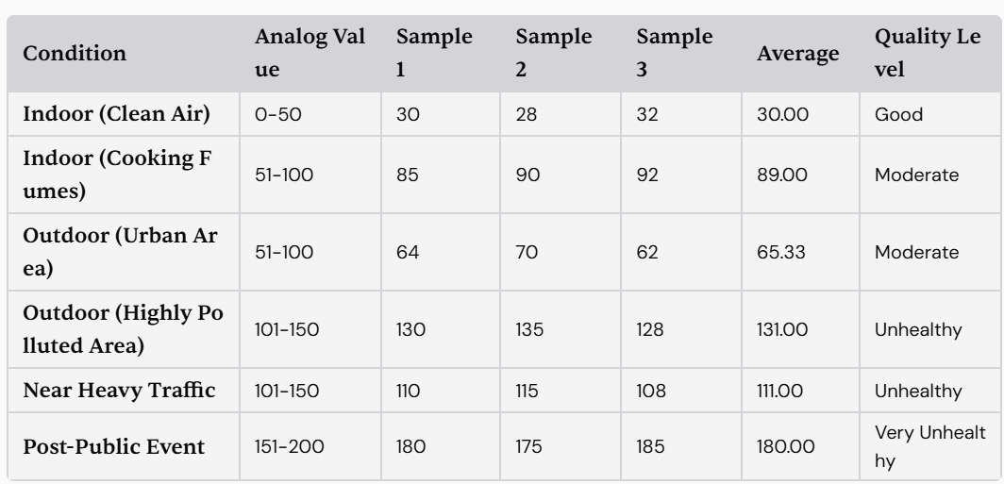
Figure 8.1 Air quality table for MQ 135 gas sensor

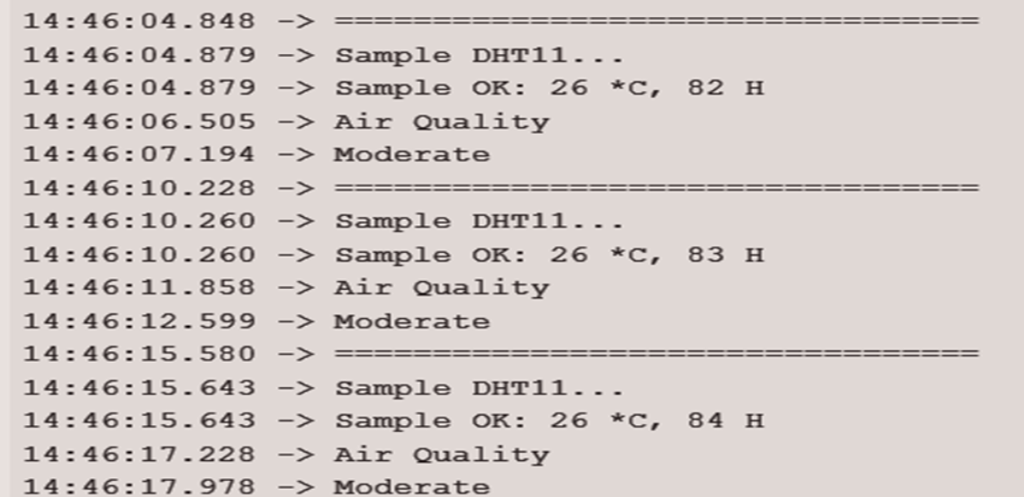
Figure 8.2 Results of air quality monitoring system in serial monitor

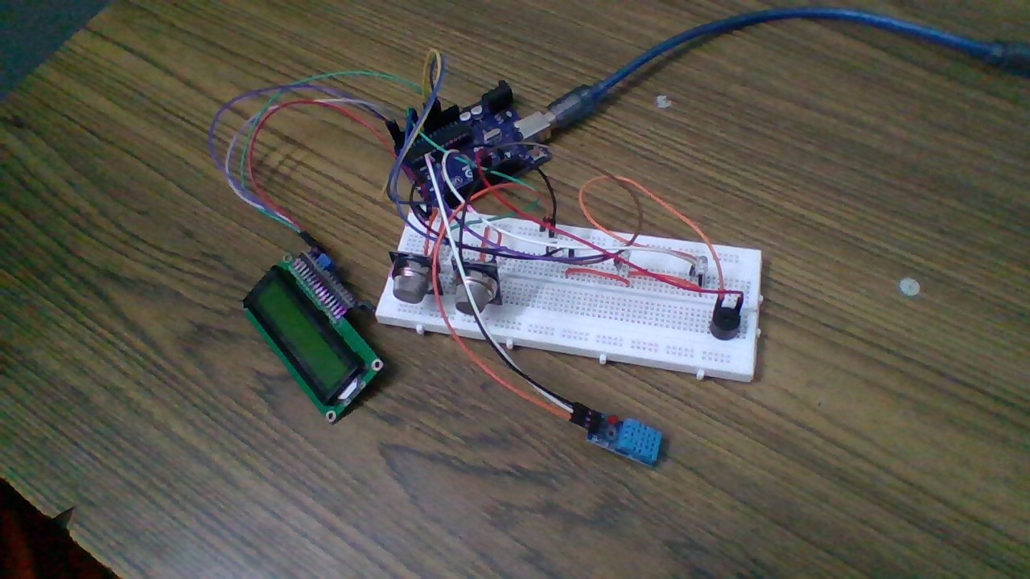
Figure 8.3 Air quality Monitoring System using Arduino

CONCLUSION
9.1 Summary of Key Achievements
The Air Quality Monitoring System project achieved significant milestones in demonstrating the feasibility and efficacy of real-time air quality monitoring using low-cost, accessible technologies. Through the successful integration of the Arduino Uno, MQ-135, and MQ-5 sensors, the system provides reliable measurements of key air pollutants, including CO2 and LPG. The project culminated in a functional prototype that combines accurate sensor data with a user-friendly LCD interface, enabling immediate visibility of air quality metrics.
Furthermore, thorough testing across various environments validated the sensor data, revealing trends in air quality that correlate with traffic patterns and environmental conditions. The successful implementation of calibration procedures and rigorous data collection methods ensured the integrity of the findings. Importantly, the project has the potential to raise community awareness about air quality issues, encouraging proactive engagement in environmental monitoring and health initiatives. These achievements underscore the system’s role as a critical tool in understanding and addressing public health risks associated with air pollution.

9.2 Contributions to Air Quality Awareness
This project significantly contributes to raising awareness about air quality issues through the development and implementation of the Air Quality Monitoring System. By providing accessible real-time data on air pollutants, the system empowers individuals and communities to better understand the air quality in their environments. The project emphasizes the relationship between local pollution sources, such as vehicular emissions, and public health, illustrating how day-to-day activities impact air quality levels.
Moreover, by utilizing cost-effective technology, the project demonstrates that communities can adopt similar systems, enabling them to monitor and advocate for improvements in air quality. The findings can inform public health campaigns and local regulations aimed at reducing pollution exposure, creating a more informed and health-conscious community. As broader environmental awareness continues to gain momentum, the project exemplifies how technology can directly contribute to tangible improvements in public health and initiative development aimed at combating air quality challenges.

9.3 Reflection on Project Goals
Reflecting on the project goals, the development of the Air Quality Monitoring System successfully aligned with the initial intentions to create an accessible and effective means of monitoring local air quality. The prototype met the objective of accurately measuring key pollutants while serving as a user-friendly system capable of engaging the community. Through the testing processes, significant data were collected that validated the project’s central premise—that low-cost, community-based monitoring can yield actionable insights into air quality trends and influences.
Moreover, the project's iterative design allowed for continuous improvement, addressing challenges that arose during implementation and calibrating sensors for optimal accuracy. The educational aspect of the project proved to be vital, as it provided knowledge to community members regarding the factors affecting air quality. Overall, the project not only achieved its technical goals but also fostered a greater consciousness of air quality issues, motivating further exploration of environmental monitoring initiatives within the community.

9.4 Overall Significance of Findings
The overall significance of the findings from the Air Quality Monitoring System project lies in the establishment of a reliable framework for local air quality assessment and community engagement. The data collected provide valuable insights into the relationship between pollution levels and real-world factors, such as traffic patterns and weather conditions. These findings underscore the pressing need for continuous air quality monitoring, as they reveal the dynamic nature of pollutants and their direct impact on public health.
Moreover, the project illustrates how accessible technology can enable ordinary citizens to take an active role in environmental monitoring, highlighting a shift toward grassroots initiatives in public health advocacy. By demonstrating the effectiveness of low-cost sensors, the project paves the way for broader adoption of similar systems, leading to enhanced data collection and analysis on air quality. Ultimately, the significance of these findings extends beyond academic interest, serving as a turning point in community awareness and action toward addressing air quality challenges.

FUTURE APPROACH
11.1 Proposed System Enhancements
Future directions for the Air Quality Monitoring System focus on several enhancements to expand its capabilities and usability. One key enhancement could be to integrate additional sensors that measure a wider range of pollutants, such as nitrogen dioxide (NO2), sulfur dioxide (SO2), and particulate matter (PM2.5/PM10). By broadening the spectrum of detectable gases, the system can provide a more comprehensive air quality profile for users.
Furthermore, smoothening the user interface and enhancing visualization capabilities, such as incorporating smartphone applications or web-based dashboards for remote data access, could facilitate better user engagement and understanding. Upgrading to a Wi-Fi or Bluetooth-enabled module would allow for real-time data transmission and logging, empowering users to track air quality trends over time and receive alerts. Overall, these proposed enhancements aim to increase the system's accessibility, reliability, and impact on community awareness of air quality issues.
11.2 Exploration of Additional Sensors
Exploring additional sensors is a crucial future direction for the Air Quality Monitoring System, as it enables the detection of a more extensive range of air pollutants. Integrating sensors such as the MQ-7, which measures carbon monoxide (CO), or the SDS011 laser sensor for particulate matter could provide more comprehensive data on the air quality impact on public health.
Additionally, incorporating volatile organic compound (VOC) sensors would help identify indoor air quality concerns often linked to household products. Research and development should focus on understanding how these various pollutants interact and contribute to overall air quality. Moreover, testing these additional sensors in conjunction with existing ones could lead to innovative approaches for data interpretation, allowing users to receive valuable insights about air quality in diverse settings, from urban areas to residential neighborhoods.
11.3 Potential Integration with Smart Technology
The potential integration of smart technology into the Air Quality Monitoring System presents exciting opportunities for enhancing its functionality and user experience. By incorporating Internet of Things (IoT) capabilities, users could access real-time air quality data on their smartphones or computers, improving user engagement and proactive monitoring of outdoor and indoor environments.
Smart technology could enable the system to send alerts directly to users when pollution levels exceed safety thresholds, fostering prompt actions and increasing community awareness. Additionally, utilizing cloud storage to log historical air quality data would allow for long-term trend analyses, aiding researchers and policymakers in making informed decisions regarding air quality regulations. Collaborative platforms connecting users with similar monitoring systems could further promote community involvement in environmental stewardship, allowing neighborhoods to share data, plan initiatives, and advocate for cleaner air collectively.
11.4 Long-term Monitoring Options
Long-term monitoring options are vital for understanding the dynamics of air quality over time, revealing trends, and identifying pollution sources in various environments. Future development could include exploring fixed station deployments for the Air Quality Monitoring System in key locations, such as schools, parks, and high-traffic areas, to provide continuous monitoring and data collection.

Additionally, designing a mobile version of the system that can be easily transported and set up in various locations would allow for flexible, long-term assessments of changing air quality conditions across different neighborhoods. Incorporating data analysis software that can identify seasonal patterns and correlations with health issues would enhance the project's relevance. This long-term approach to monitoring not only provides critical data for community initiatives but also strengthens the case for policy advocacy and environmental action.

11.5 Partnerships and Collaborations for Expansion
Forming partnerships and collaborations is essential for the continued expansion and impact of the Air Quality Monitoring System. Engaging with local governmental agencies, non-profit organizations, and educational institutions could support research initiatives and grant opportunities, fostering a collaborative environment for environmental monitoring.
These partnerships could facilitate community workshops aimed at raising awareness about air quality issues, promoting usage of the monitoring system, and gathering user feedback for iterative improvements. Furthermore, collaboration with data scientists and environmental experts can help analyze air quality data effectively, informing further developments of the system and aiding policymakers in the implementation of effective regulations. By leveraging external expertise and resources, the project can significantly amplify its reach and impact, transforming community engagement with air quality issues into actionable strategies for improvement.

REFERENCES:
- Saini, Jagriti, Maitreyee Dutta, and Gonçalo Marques. "A comprehensive review on indoor air quality monitoring systems for enhanced public health." Sustainable environment research 30 (2020): 1-12.

- Saini, J., Dutta, M., & Marques, G. (2020). A comprehensive review on indoor air quality monitoring systems for enhanced public health. Sustainable environment research, 30, 1-12
.
- Karagulian, Federico, et al. "Review of the performance of low-cost sensors for air quality monitoring." Atmosphere 10.9 (2019): 506
.
- Morawska, Lidia, et al. "Applications of low-cost sensing technologies for air quality monitoring and exposure assessment: How far have they gone?." Environment international 116 (2018): 286-299.

- Sokhi, Ranjeet S., et al. "Advances in air quality research–current and emerging challenges." Atmospheric Chemistry and Physics Discussions 2021 (2021): 1-133.

- Kumari, Shweta, and Manish Kumar Jain. "A critical review on air quality index." Environmental Pollution: Select Proceedings of ICWEES-2016 (2018): 87-102.

- Tran, Vinh Van, Duckshin Park, and Young-Chul Lee. "Indoor air pollution, related human diseases, and recent trends in the control and improvement of indoor air quality." International journal of environmental research and public health 17.8 (2020): 2927.

- Sabado, Wilber B. "The Use of Microcontrollers in Air Quality Monitoring: A Systematic Literature Review." International Journal of Computing Sciences Research 8 (2024): 3268-3297

.
- McKercher, G. R., Salmond, J. A., & Vanos, J. K. (2017). Characteristics and applications of small, portable gaseous air pollution monitors. Environmental Pollution, 223, 102-110.

